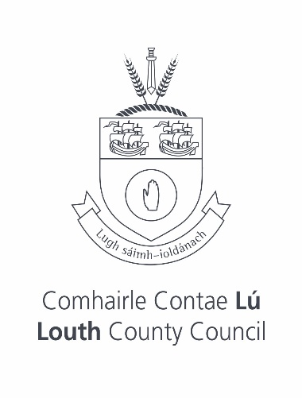

Ardee Civic Awards 2024 Recipients

GRACE CONWAY DOWLING
HUGH CALLAGHAN
LIAM HAND
THE STAFF OF ST. JOSEPH’S HOSPITAL, ARDEE
CASTLEBELLINGHAM & KILSARAN FESTIVE LIGHTS COMMITTEE
LOUTH ABBEY VINTAGE CLUB
SINEAD COWLEY
ARDEE ACTIVE RETIREMENT GROUP
JUNE MCGREAL
CRAIG LENNON
EIMEAR BYRNE

