HAVE YOUR SAY ON THE LOUTH LOCAL DEVELOPMENT STRATEGY 2023-2027

Tapping Local Knowledge – Public Consultations

With a budget of €4.9 million for County Louth, Louth Local Development on behalf of Louth Local Development Committee (LCDC) in collaboration with Louth County Council has begun the process of creating the LEADER Local Development Strategy (LDS) 2023-2027, which will set a roadmap for LEADER investment over the next 5 years.

As part of the public consultation process, supported by KPMG Ireland, we invite all interested individuals, communities, and businesses to attend one of the following public meetings to give voice to how LEADER funding should be invested and to enable your wishes to be captured within the strategy.

For all individuals, groups, and businesses with an interest in funding, these are must-attend events!

Join us for these important discussions on the following dates and locations:

Monday, May 15th: Dundalk
- 7pm-9pm, Crowne Plaza Hotel, Dundalk
Tuesday, May 16th: Carlingford
- 7pm-9pm, Four Seasons Hotel, Carlingford
Wednesday, May 17th: Drogheda
- 7pm-9pm, The d Hotel, Drogheda
Thursday, May 18th: Dunleer
- 7pm-9pm, The Market House, Dunleer

The meetings are open to all, but registration is welcome by clicking
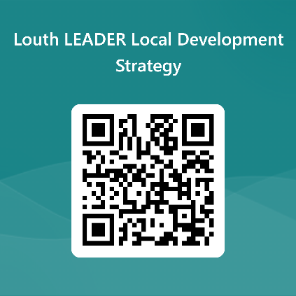
https://forms.office.com/e/dk1xamQW11 or by scanning the following code:

For more information, contact: mary.oneill@lldc.ie.

Online Survey
You can express your views through an online survey as well, which can be accessed by clicking: https://ecv.microsoft.com/ECRZfjNj2q or by scanning the following code:


The survey can be completed until 5pm on Friday 19th May.

Written Submissions
If you would like to make a written submission to the LDS, please contact:
IE-FMlouthlocaldevelopmentstrategy@kpmg.ie

Thank You for Your Participation
Your engagement with the public meetings, the survey, and written submission will help inform and guide the development of a bespoke Local Development Strategy that seeks to address the needs of your community, social enterprises and businesses and drive sustainable economic and community development across the county.

