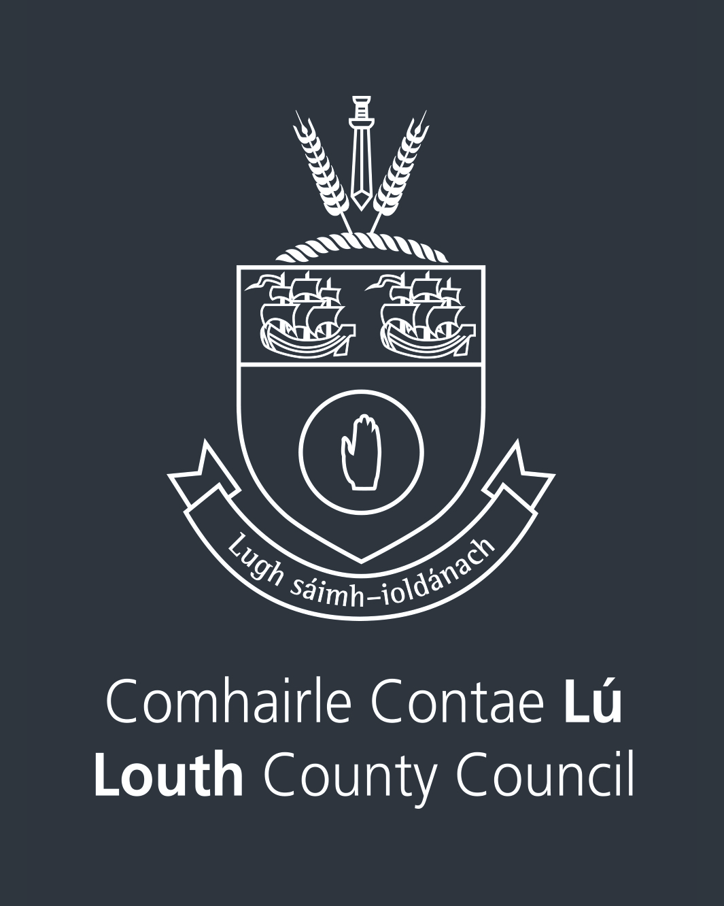
Direct Debit Mandate
LOUTH COUNTY COUNCIL
COMHAIRLE CONTAE LU
By signing this mandate form, you authorise (A) Louth County Council to send instructions to your bank to debit your account and (B) your bank to debit your account in accordance with the instructions from Louth County Council.
As part of your rights, you are entitled to a refund from your bank under the terms and conditions of your agreement with your bank. A refund must be claimed within 8 weeks starting from the date on which your account was debited. Your rights are explained in a statement that you can obtain from your bank.
Please complete all the fields marked *

Customer A/C No. *

Customer Name *

Customer Address *

Bank Details – BIC *

Bank Details – IBAN *
L | O | U | T | H |  | C | O | U | N | T | Y |  | C | O | U | N | C | I | L

Creditor’s name

I | E | 4 | 7 | Z | Z | Z | 3 | 0 | 2 | 1 | 1 | 7
Creditor identifier

C | O | U | N | T | Y |  | H | A | L | L
M | I | L | L | E | N | N | I | U | M |  | C | E | N | T | R | E
D | U | N | D | A | L | K
C | O |  | L | O | U | T | H
I | R | E | L | A | N | D
Creditor address

Country

Type of payment * Recurring payment One off payment

Term of payment * __________ Months Until Account is Clear

Contact Telephone Number * ___________________________________
Contact Email Address * ___________________________________

Signature Date: ______________

Account Manager Date: _______________

Direct Debits will be processed on the 15th of each month. If there are no arrears on your account, direct debits will be processed between February and November each year.
If you have ARREARS on your account, please complete the form overleaf.

