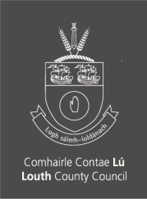
LOUTH COUNTY COUNCIL

Commuters travelling Southbound on the M1, please use Junction 11 instead of Junction 10.

Commuters travelling Northbound, please use Junction 9 instead of Junction 10 to access Drogheda due to ongoing roadworks at the Hill of Rath Roundabout.

