Louth County Council


Section 254 Telecommunications Licence Form

Planning Section, Town Hall, Crowe Street, Dundalk, Co. Louth A91 W20C
or online to planningadmin@louthcoco.ie

APPLICATION FORM FOR A TELECOMMUNICATIONS LICENCE UNDER SECTION 254 OF THE LOCAL GOVERNMENT (PLANNING AND DEVELOPMENT) ACT, 2000 (AS AMENDED)

- APPLICANT NAME: |  |  |  | DATE:
 | Last | First

- APPLICANT
ADDRESS:
 | Street Address
 | Town | County | Eircode

- PHONE: |  | EMAIL:

- ADDRESS FOR WHICH THE
LICENCE IS REQUIRED:

- SITE LOCATION IS PUBLIC ROAD? Yes ☐ No ☐

- DESCRIPTION OF DEVELOPMENT:

- DIMENSION OF THE PROPOSED TELECOMMUNICATIONS STRUCTURE(S):

- PRECISE LOCATION OF STRUCTURE(S):
To be Indicated on a Site Layout Plan

IF APPLICABLE, PLEASE PROVIDE PLANNING REFERENCE NO.
- IS THERE PLANNING PERMISSION ON THE SITE? YES NO ☐ ☐

- IS THE DEVELOPMENT LOCATED IN A SENSITIVE
AREA WHERE THERE IS A REQUIREMENT YES NO
FOR APPROPRIATE ASSESSMENT? ☐ ☐

- HAS A SCREENING REPORT FOR APPROPRIATE YES NO REPORT YES NO
ASSESSMENT BEEN UNDERTAKEN? ☐ ☐ ENCLOSED? ☐ ☐

- DOES THE DEVELOPMENT ENDANGER PUBLIC
SAFETY BY REASON OF TRAFFIC HAZARD OR YES NO
OBSTRUCTION OF ROAD? ☐ ☐

- IS THE SITE LOCATED WITHIN AN YES NO
ARCHITECTURAL CONSERVATION AREA (ACA)? ☐ ☐

- IS THE SITE LOCATED WITHIN AN AREA YES NO
DESIGANTED A NATIONAL MONUMENT? ☐ ☐

- DURATION FOR WHICH LICENCE IS SOUGHT?

- ARE THERE OTHER TELECOMMUNICATION
STRUCTURES WITHIN 1 KILOMETRE OF THE YES NO
PROPOSED SITE? ☐ ☐

IF YES, PLEASE PROVIDE DETAILS WHY
CO-LOCATION IS NOT POSSIBLE:

PLEASE SEE OVERLEAF FOR INSTRUCTIONS

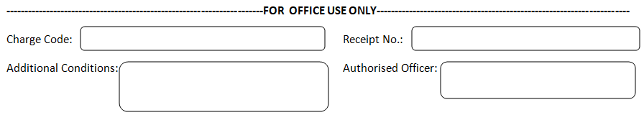

NOTES FOR APPLICANTS

Section 254 Applications will be assessed in accordance with Section 254 of the Planning and Development Act 2000, as amended.

Any such proposed development being applied for under this section must be on the public road and not on private lands.

Section 254 (5) of the Planning and Development Act, 2000, as amended requires the Planning Authority to have regard to-
- Proper planning and sustainable development of the area
- Any relevant provisions of the development plan, or local area plan
- The number and location of existing appliances, apparatuses or structures on, under, over or along the public road, and
- The convenience and safety of road users including pedestrians.

You are advised to use the Checklist below and submit the information set out in accordance with this checklist. Where information is lacking or unclear a refusal in respect of the S254 licence may issue.

Any person may, in relation to the granting, refusing, withdrawing or continuing of a licence under this section or to the conditions specified by the planning authority for such a licence, appeal to An Bord Pleanála.

CHECKLIST FOR APPLICANT BEFORE SUBMITTING:

- Application form is completed in full and signed | ☐
- Site location map enclosed | ☐
- Site layout plan enclosed | ☐
- Details including elevations of proposed telecommunications structure,  design details, height, colour etc. enclosed | ☐
- Details of access arrangements to public road for purposes of construction and maintenance thereafter set out | ☐
- Application fee enclosed | ☐
- Appropriate assessment screening report enclosed | ☐
- Details of assessment of other telecommunication structures located in the area as appropriate | ☐
- General statement as to how the application licence is in accordance with Louth County Development Plan policy | ☐

