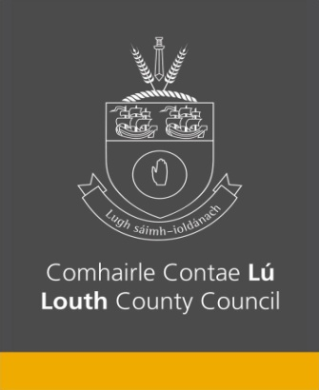

Notice of the County Louth Joint Policing Committee

Statutory Public Meetings 2023

Members of the public are invited to attend:

Tuesday 19th September | Ardee Parish Centre, Ardee Co Louth | 6.30pm -8.00pm
Wednesday 20th September | The Lisdoo Dundalk, Co Louth | 6.30pm -8.00pm
Thursday 21st September | The D Hotel Drogheda, Co Louth | 6.30pm -8.00pm

The theme of the public meetings will be Personal Safety & Crime Prevention and there will be a number of speakers and presentations on these topics.

Members of the public can raise questions at the meetings or submit questions in advance of the meetings.

Contact communitysection@louthcoco.ie or you can call 042 9324389 for further details.

Questions will be accepted from any person affected by the policing of the area. All questions should be received no later than 5.00pm on Thursday 14th September 2023 and must be accompanied by a name, address and contact numbers. These details will remain confidential.

Please note that the Joint Policing Committee may not consider matters relating to specific criminal investigation or prosecution or matters relating to the security of the State.

