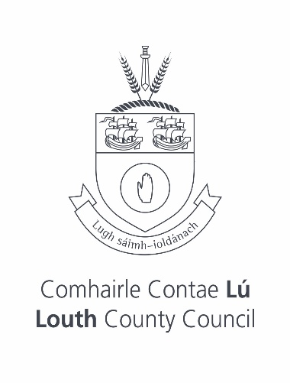

Ardee Civic Awards 2025 Recipients

Sean Geeney
Gerry Reynolds
Abbie Sheridan
Michael Murphy
Jackie Brennan
Raymond Torris
Local Vocals
Boyne Fishermen Recovery & Rescue
Mid Louth Men’s Shed

