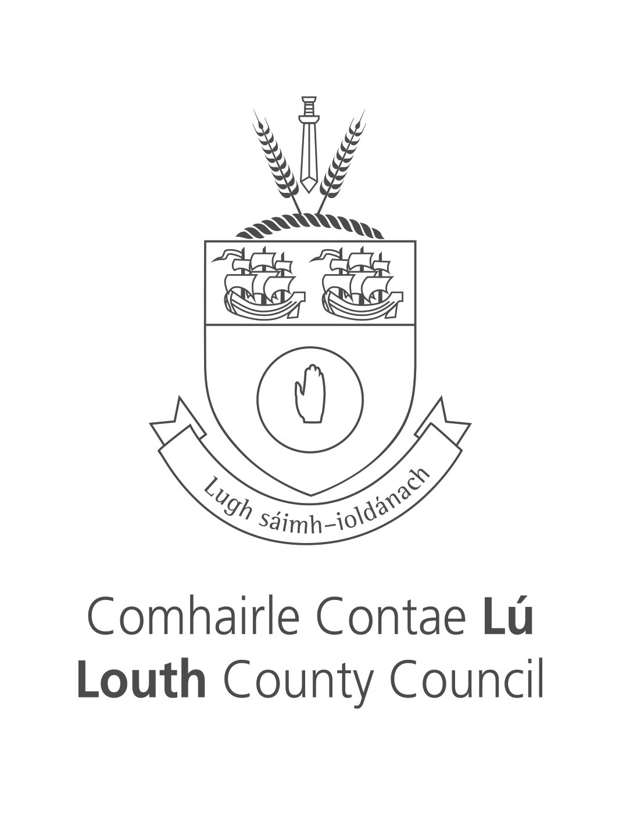

Ukrainian Humanitarian
Temporary Accommodation
Complaints Procedure
October 2022

INTRODUCTION
Louth County Council is committed to providing temporary emergency accommodation in an efficient and courteous manner to Ukrainian refugees assigned by Government to Louth County Council.

This complaints procedure sets out what to do if you are dissatisfied with the quality of service being provided to you.

Confidentiality
All complaints will be handled sensitively and in confidence by centre staff and the Council, but sometimes they may need to consult other people involved.

Complaint Handling – Step by Step

Fault or Complaint?
There is a difference between making a formal complaint and reporting a fault. For
example, contacting the management company to report a leak is reporting a fault. It
only becomes a complaint if whatever remedial action promised does not materialise.

Therefore, our definition of “complaint” is when your dissatisfaction has not been
addressed. This dissatisfaction can apply to the way we deliver services or to services not delivered to you to which you believe you are entitled.

In the event of an emergency situation i.e. physical/sexual assault you should ring 999 or 112.

Informal first
In the first instance, all complaints should be reported informally, i.e. verbally, to your house / centre manager / Council social worker to be resolved. Only after this step should you put your complaint in writing.

Stage 1

Make an Informal (verbal) Complaint to the Accommodation Centre Manager.
The centre manager will try their best to resolve your issue quickly and informally. If you want to make an informal complaint, you must tell the centre manager immediately if you become unhappy with the services they are providing.

If the complaint is not resolved informally by your centre manager you may submit a formal complaint, in writing, to your centre manager.

Make an Informal (verbal) Complaint to the Duty Social Worker
If you feel your complaint cannot be handled by your house /centre manager, you feel uncomfortable dealing with your centre manager, or your complaint is about the centre manager themselves, you should refer to the duty social worker in Louth County Council to informally try to resolve your dissatisfaction.

To contact Drogheda Social Worker Arja Cullen or Dundalk Social Worker Danielle McMahon phone 042 933 5457.

Stage 2

Make a Formal Complaint to the Accommodation Centre Manager.
If you are not satisfied with how the centre manager handles your informal complaint, you may complain formally in writing, this should outline the nature of the complaint, should be signed and dated and given directly to the Centre Manager. The Centre Manager should respond to you within 5 working days.

Make a formal (written) Complaint to the Duty Social Worker
If the complaint is not resolved informally by the duty social worker you may submit a formal complaint, in writing to Louth County Council Customer Service, clearly marked, ‘Ukrainian Response’.

This should outline the nature of the complaint, should be signed and dated and emailed, or posted to the duty social worker. The Duty Social Worker will respond to you within 5 working days.

Stage 3

Make a Formal Complaint to Louth County Council.
If, having gone through the above process, you believe your centre or the duty social worker has not handled your complaint satisfactorily; you can complete the attached form, e-mail complaints@louthcoco.ie or post it to Louth County Council, County Hall, Millennium Centre, Dundalk, Co Louth, A91 KFW6, outlining what your original complaint was. You should attach a copy of the original complaint and the centre manager’s or social worker’s response, if you wish.

Your complaint will be logged to ensure it is appropriately investigated by a member of the Ukrainian Humanitarian Response team. We will acknowledge complaints within 5 working days normally and do our utmost to deal with them within 15 working days.

Stage 4 – Appeal the Formal Complaint to Louth County Council
In the event that you are not happy with the outcome of the formal complaint decision by Louth County Council, you may seek a review of this decision by writing to the Director of Ukrainian Response seeking an internal review of the matter and enclose a copy of all correspondence of the complaint, You should submit this within 4 weeks from the date of the Louth County Council formal complaint decision. The appeal will be acknowledged within 3 days.

The review will involve a complete reconsideration of the matter by a more senior member of the staff and the Director of Service will endeavor to issue a decision or update directly to you within 4 weeks of appeal date. A decision at this point will be regarded as a final response from Louth County Council.

What should I include in my complaint?

Formal Centre Complaints’ should be made in writing and given directly to the Accommodation Centre Manger.

Formal complaints must include the following:
- Your contact details including your name, address of Centre, ID Number, email and phone number.
- Full details of the complaint – this should be as detailed as possible to all for full investigation.

Formal Complaints and Appeal’s to Louth County Council, should be emailed to complaints@louthcoco.ie or posted to Louth County Council, County Hall, Millennium Centre, Dundalk, Co Louth, A91 KFW6.

GDPR, please note by making a complaint to the council you are consenting to the Complaints Procedure as listed in this document, your data will be shared with relevant staff where necessary, and the processing of your data is carried out on the basis of receiving consent. [Article 6(1)(a) of the General Data Protection Regulations, 2016].

