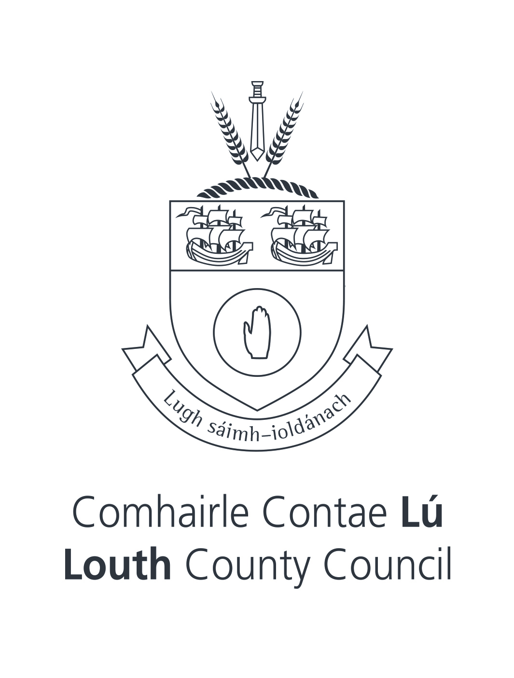

Louth Library Service

Collection Development Policy

Louth Library Service 2023

Introduction:
In devising this collection development policy, Louth Library Service has regard to its statutory obligations as a public library service and to the role of a public library service in fostering and maintaining a democratic society. It is underpinned by Our Public Libraries 2022, a progressive and ambitious public library strategy, focusing on the core functions of the Library Service, bringing greater structure and consistency to the library’s role in literacy support, supporting lifelong learning opportunities and establishing the library as a key place for accessing reliable and authoritative information.

Purpose:
This policy acts as a framework document to determine the selection, maintenance, retention and disposal of materials held in Louth County Libraries’ collections. It provides staff members with professional guidelines while acquainting stakeholders with our methodology. Ultimately, our Collection Development Policy enables us to provide the best possible service to our borrowers in accordance with our mission to provide for their life-long educational, recreational and informational needs and our strategic goals set out in Louth Library Service Development Programme 2020 – 2025:

- to support and enable the development of literacy skills, reading, creativity and innovation, and helping people realise their potential
- Louth Library Service supports and facilitates learning, providing free access to lifelong learning, and healthy living.
- Louth Library Service inspires creativity within communities and provides welcoming and inclusive spaces for all.

Objectives:
Louth Library Service recognises the changing needs of our borrowers and endeavours to meet those needs. We further recognise that technology is ever-evolving and we must stay relevant in the formats and materials we offer. When using the term ‘materials’ in this policy, we intend the term to include print, audio-visual and digital items. Louth Library Service prides itself on its innovative stance on collection development and management and we intend to build on that innovation by continuing to provide state of-the-art electronic services in conjunction with more traditional formats. We further recognise that as the population of Louth increases, our collections must reflect the increasingly diverse needs of our borrowers. Our collections will, as far as is practical, meet distinct demographic, linguistic and cultural requirements. We will also serve the different needs of varying age groups and appreciate that the needs of our youngest borrowers are as relevant as those of borrowers who have been using our services for decades. Realistically, however, library materials are selected on the basis of their information, educational and recreational merits and are designed to meet the needs of a broad populace. Our remit requires an emphasis on materials that will be of value to the general public.

Acquisitions:
We are legally obliged to purchase materials from those library suppliers who have won national tendering contracts. While the Acquisitions section is primarily involved in book purchasing, branch library staff members play a strong role in requesting specific stock for their branch. Branch staff members are also the conduit through which borrower suggestions for purchase are made. Borrowers’ suggestions for purchase will be reviewed by Acquisitions staff members for inclusion in the collection. Suggestions are subject to regular selection criteria.

Selection Criteria:
Criteria for selection of materials include the following:

- Relevance to the interests and needs of the community
- Suitability of subject, style and level for intended audience
- Suitability of format to Library circulation and use
- Price, availability and Acquisitions budget
- Reputation and qualifications of editor, author or publisher
- Accuracy, reliability and currency of material
- Ability to fill a subject gap
- Local significance of the subject or author
- Cultural interest of the subject or author
- Relevance to the existing collection’s strengths and weaknesses
- Updating and replacing older material
Stock Management:
Louth County Council allocates a budget annually for the purchase of library books, audio, film, music, newspapers and special collections. Maximum use is now also made of the National Library Management System, Spydus, when ordering stock. The National Library Management system offers library members an opportunity to search, reserve and receive library items from any of the 31 local authority library services around the country. This enhances the service we provide for patrons around the area of stock management.

Weeding Policy:
Weeding is a vital component in maintaining a modern, relevant and broad ranging collection that is responsive to the communities’ needs. Stock should be regularly reviewed to ensure it continues to be relevant and that it is physically fit for purpose. This process should be led by a senior member of staff in the branch or a member of staff with a specialist knowledge/interest in stock being considered for withdrawal.
Information from the library management system as well as professional librarian input should be used to help make decisions about the need for additional copies, replacement of heavily used items, withdrawal of outdated titles and titles no longer of interest.
Withdrawal of materials frees up space for new materials and helps maintain the overall quality of our collection.

The following criteria are considered when assessing stock for withdrawal:
- Material in poor physical condition or at risk of damaging other material
- Out of date – if the information is incorrect or refers to out-dated processes/advice (technology, finance, health advice, travel etc)
- Replacement by newer edition and/or availability of more up-to-date subject material
- Duplicate copies of material not borrowed for 1 year
- Duplicate copies held in storage
- Past use and expected future use
- Availability elsewhere
- Availability of shelf-space and/or storage

If an item has not been issued for a while it should not automatically be withdrawn if it is of:
- Local, historical, Irish interest
- Rare/valuable item
- Literary merit- it may be required at some point in the future
The following criteria are applied when assessing such items:
- Condition of the item – can it be easily replaced?
- Relevance to the scope of a special collection
- Is the item out of print?
- Has it been well used and should a new copy be bought (if available)
- Are there multiple copies of the item?
- Is it the last lending copy on the system?

Various disposal methods are used when withdrawing stock including:
- Keep in storage
- Donate to local schools/organisations
- Send to BetterWorld Books
- Recycle

Collections:
Louth Library Services’ general collection comprises of fiction, non-fiction and reference material specifically categorised for the varying needs of adults, teenagers and children. Our audio-visual material comprises of music CDs, talking books on CD, DVDs and PC/Xbox and Playstation games. Louth Library Service also works with specialist suppliers to provide downloadable material, thus allowing for access beyond actual library branches. Eservices continue to expand. The Library App allows borrowers to download eBooks and eAudiobooks, as well as newspapers and magazines.

Local Studies & Archives
Louth Library Service Local Studies' Department is a reference and research service dedicated to preserving and enhancing the collective memory of Louth County Council. We offer access to the history and heritage of County Louth and continuously collect, catalogue and preserve all types of Louth-related material. The Library holds a wide range of material on the history, geography, antiquities, archaeology, folklore and culture of Louth County Council. The collection consists of books, journals, newspapers, photographs, audio visual material, manuscripts, maps and microform.
Louth Library Service, within existing resources aims to acquire:

- Material which was created or published locally or created or published outside the locality but with local relevance.
- Material which documents the experience of local citizens
- Material which documents significant aspects of the history, social or cultural life of the local community and enhances the collection.
Donations to our Local Studies collection can only be accepted upon approval and must be in excellent condition. We welcome donations of local history materials that can be integrated into existing collections and that fit collection development policies. Acceptance, classifications, shelving, access, location and disposal will be determined by Louth County Libraries.

Intellectual freedom and censorship:
Louth Library Service aspires to hold a balanced collection available to all. We subscribe to the principles in the International Federation of Library Associations and Institutions Statement on Libraries and Intellectual Freedom. We choose material with regard for the laws of the land, and as such, we will not stock items that are offensive or pornographic, or discriminatory based on the nine grounds outlined in the Equal Status Acts. However, it is not our intention, desire, or policy to restrict the freedom of our patrons to read what they want. We will not censor on the basis of whether topics are disapproved of by certain sections of the community. We strive to have a collection that is inclusive, age appropriate, balanced and fair. Not only do we offer collections for information and cultural enjoyment, we also have a role in collecting for posterity and to enable future research.

Age appropriate material:
The responsibility for ensuring that any child or young person borrows age appropriate content lies with the parent or guardian. Our Library Management System restricts children from borrowing items intended for young adults or adults. No member under the age of 18 can borrow DVDs rated 18. Please see the table for the types of content available to the different membership categories.

Membership type | Age range | Can borrow or reserve Young Adult items | Can borrow or reserve Adult items | Can borrow DVDs rated
Child | 0 - 11 | No | No | E, G, PG
Y12 | 12 – 14 | Yes | No | E, G, PG, 12
Y15 | 15 – 17 | Yes | Yes | E, G, PG, 12 15+

Parents or guardians decide which category a child or young person can borrow when registering or renewing their library membership. If a parent or guardian has any questions, a member of staff will happily talk you through the age ranges and membership categories. A parent or guardian can also change the membership category during the life of the membership. Parents or guardians are responsible for ebooks and digital items borrowed by their children.

Complaints:
If you are concerned about an item held by Louth Library Service, you can email libraryhelpdesk@louthcoco.ie. Please make sure to include the title and author, and include the year, edition number and ISBN if there is more than one edition of the title. To ensure a fair process, reviewing the complaint is likely to take time. We promise to deal with you respectfully and confidentially. We expect complaints or expressions of concern to respect library staff as set out in Louth County Council Code of Conduct.

Review:
This policy will be reviewed periodically to ensure that it is responsive to our changing needs.

https://www.librariesireland.ie/local-libraries/learn-about-your-local-library/libraries-ireland-2022
https://www.louthcoco.ie/en/services/library/louth-library-service-development-programme-2020-2025/
https://www.ifla.org/resources/?oPubId=608
https://www.louthcoco.ie/en/policy-and-redress/freedom-of-information/who-we-are-and-what-we-do/customer-charter

