


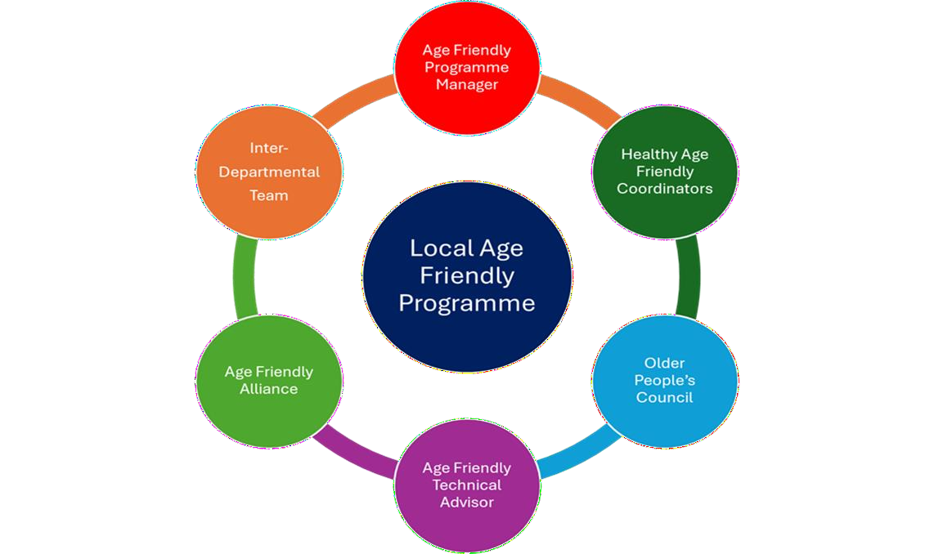
Did you know that there’s a Local Government Shared Service called Age Friendly Ireland?

The national office for the shared service is hosted in Meath County Council.

Age Friendly Ireland manages Ireland’s affiliation to the World Health
Organisation’s Global Network for Age Friendly Cities and Communities. In 2019, the WHO announced that Ireland was the first country in the world to be Age Friendly because all local authority areas have signed up to their global framework and we are at an advance stage of implementing age friendly strategies.

Each local authority has a local Age Friendly Programme that manages a local strategy to support older people in the community as part of a multi-stakeholder response to population ageing.

All local authorities work closely with the age friendly shared service (Age Friendly Ireland) under an MOU agreement.

Your Local Age Friendly Programme

F o r M o r e I n f o r m a t i o n Age Friendly Ireland Meath County Council
T. +353 46 9032170
agefriendlyireland@meathcoco.ie www.agefriendlyireland.ie
www.agefriendlyhomes.ie

Your Age Friendly Alliance

The Age Friendly Alliance is a high-level interagency group, usually chaired by the Chief Executive of the local authority. Members include senior management representation from local government, An Garda Siochana, the Health Service Executive, the Education and Training Board, Transport services, universities and the business community through the Chamber of Commerce. The Alliance is responsible for the development, implementation and monitoring of the local Age Friendly Strategy.

Your Age Friendly Older People’s Council (OPC) Chair of your OPC: Joe Grogan

The Older People’s Council [OPC] is a citizen-based forum that provides an opportunity for older people to work with the local authority and Age Friendly Alliance to identify issues for older people and co-design solutions.

The OPC has an elected Executive Committee that serves a two-year term, and a wider membership base that is renewed at the Annual General Meeting. OPC representatives sit on the Age friendly Alliance and on other committees, representing the voice of older people in the community.

They also feed into a National Network of Older People’s Councils which holds a National Convention in May every year.

Your Age Friendly Programme Manager

Name: Sinead McVerry
Email: sinead.mcverry@louthcoco.ie

Each local authority has an Age Friendly Programme Manager based in the Community Section. This role is usually assigned to an Administrative Officer grade. The Programme Manager is responsible for co-ordinating all age friendly activity within the local authority and with the partners on the Alliance.

The Programme Manager takes a lead role in development and overseeing the implementation of the local Age friendly Strategy.

They also work closely with the local Older People’s Council to ensure that older people are active as co-design partners in any local projects and initiatives being rolled out.

Your Age Friendly Housing Technical Advisor

Name: Brendan McArdle, Rachel Hamiliton
Email: brendan.mcardle@louthcoco.ie, Rachel.Hamilton@louthcoco.ie

The Age Friendly Technical Advisor acts as the key point with each local authority for matters relating to age friendly housing and public realm technical queries specifically around design and delivery of infrastructure Ireland ageing population utilising universal design principles.

They provide support to colleagues in housing, planning and transportation directives, private sector developers, Approved Housing Bodies and individuals on solutions regarding age friendly housing and public realm works.

The work collaboratively with the local Age Friendly Programme Managers and the Age Friendly Ireland shared service team in relation to strategy development, planning, implementation and monitoring of objectives at local level.

Adopting best practice and using national technical standards and guidance they provide technical assistance in relation to universal design principles and crime prevention through environmental design principles to all relevant stakeholders.

If you wa nt to ref e r so me one on to the
H eal th y Ag e Frien dl y H o me s Prog ra m m e:

Email Referrals:
referralshafh@meathcoco.ie

Your Healthy Age Friendly Homes Coordinator

Name: Adrienne McCann
Email: amccann@meathcoco.ie

The Healthy Age Friendly Homes Programme aims to support older people to live in their own home with dignity and independence, for as long as possible. The programme’s ambition is to enable everyone to live longer healthier lives by keeping care close to home and expanding a range of health and social care services in the community.

It is about providing a range of alternatives for older people who may otherwise transition into long term residential care prematurely.

There is a Local Healthy Age Friendly Homes Coordinator in all 31 Local Authorities. An older person (65 years +) can self-refer into the programme or can be referred in by family/friends, elected representatives, GP’s, community groups, etc.

The local coordinators undertake home visits to older people living in the community and carry out assessments aligned to the six domains of housing, health, community/social supports, finance, climate energy and technology to assist ageing in place.

The coordinators agree a personal plan with each individual older participant and support them to access a range of services which include housing adaptation grants, home energy improvements, health appointments, befriending or other community services, or technology supports.

The programme collaborates with a broad spectrum of agencies and services, including personnel in local government, health services, transport, community and voluntary groups, Gardaí, elected members and others.



Your Age Friendly Ambassador

Name: Gavin Duffy

As part of this national programme, we have identified the opportunity for each local programme area, hosted by each local authority, to have their own Age Friendly Ambassador.

This role is carried out by a local high-profile person who represents the Age Friendly Programme on behalf of older people in their City/County. Their personal endorsement of the programme will be of enormous benefit and influence plus it provides significant value to this work.

This is an honorary position that has the potential to have a big impact but with a modest demand on time. The role of our Ambassadors is:

- Promote the need to be age friendly, and support the local Age Friendly Programme to raise awareness of Age Friendly practices
- Support the local Age Friendly Programme by encouraging local involvement in Age Friendly initiatives.
- Attend launch events when possible, this may translate to c. 4 events per year and include the yearly National Age Friendly Recognition Awards (if calendar allows).
- Provide quotes for local press releases, e.g. the launch of the local Age Friendly Strategy
- Occasionally speak to media about the importance of the Age Friendly Programme.

For more information
Age Friendly Ireland
Meath County Council
T. +353 46 9032170
agefriendlyireland@meathcoco.ie
www.agefriendlyireland.ie
www.agefriendlyhomes.ie

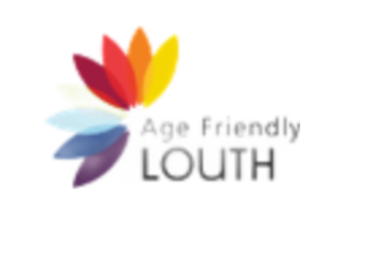
Challenging Ageism Drama Project supported by Age Friendly Louth & Creative Ireland

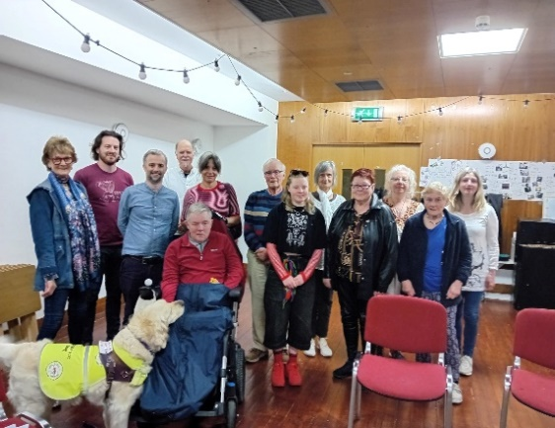

Participants in the Challenging Ageism Drama Project

One of the short films will be launched at the Louth Age Friendly Expo on 2nd October during Positive Ageing Week and will be a great way to celebrate positive ageing in Co Louth.
This is first initiative that the Louth Age Friendly Programme has delivered as part of an ongoing suite of ageism awareness initiatives. LECP 2024 Action 5.4.2.

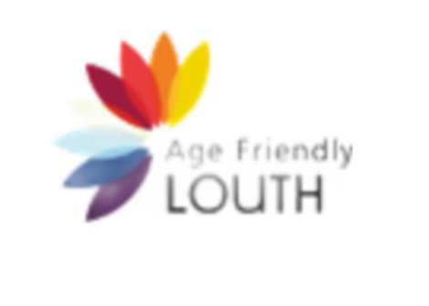

Ardee Garden Care & Repair
Ardee Tidy Towns supported by Dee Hub, An Garda Síochána and Age Friendly Louth continue to roll out this innovative pilot project.

The aim of the project is to provide free gardening services to older and vulnerable people in Ardee Town. This community-driven initiative aims to assist those in need by offering essential garden care at no cost.
The initiative has been supported by the Ardee Municipal District Elected Members as part of their Discretionary Budget 2024.

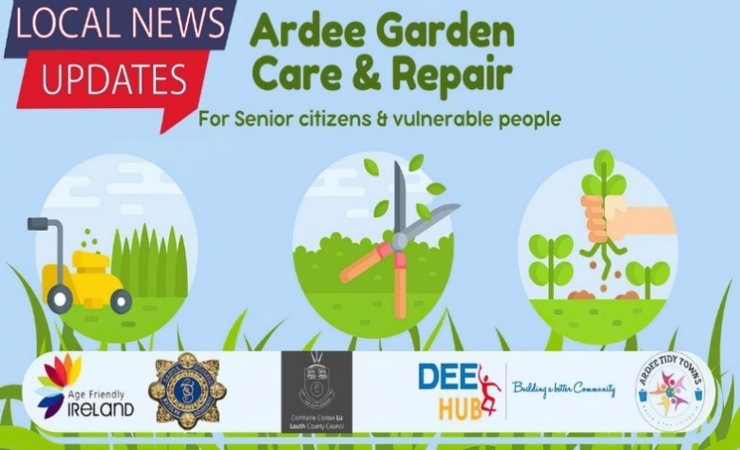

Sustainable Arts & Crafts Project at Treadagh Lodge Day Care Centre

Age Friendly Louth partnered with local artist Aga Hutchinson to provide funding for a 5-week arts and crafts course for the clients of Treadagh Lodge Day Care Centre.

Treadagh Lodge Day Care Centre provides dementia specific, person-centred care to meet the needs of the person with dementia in a warm, welcoming and safe environment while providing support and stimulation.

Aga facilitated a suite of arts and crafts workshops working with the clients at the lodge to reuse and upcycle all day everyday objects and household items. The objects and household items were transformed into practical and sustainable items for use in the new garden that is currently under way at the lodge.

Clients at the lodge created, bird feeders, bee hotels, planters, lanterns and fabric bunting. All the sustainable creations will be utilised in the new garden currently underway in the centre.

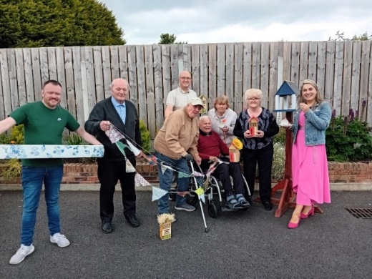

Clients and staff from Treadagh Lodge Day Care Centre Drogheda with some of their upcycled sustainable creations as part of the arts and crafts workshops supported by Age Friendly Louth.

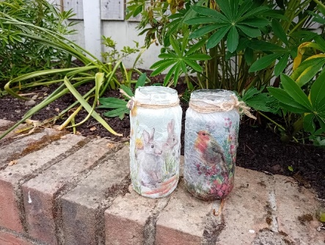
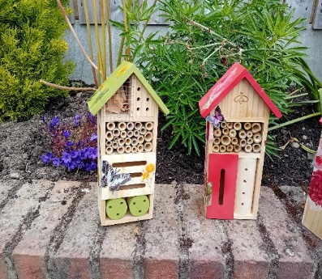
Bee Hotels and Decoupage Lanterns made from recycled objects and materials

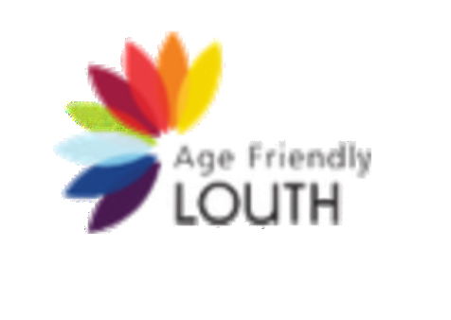

Let’s Talk Climate Action Workshop & Site Visit

Age Friendly Louth were delighted to host Gavin Harte from the Climate Action Regional Office (CARO) in Co Louth on Tuesday 30th April. Gavin hosted an interesting an engaging workshop with older people from across Co Louth on the topic of climate action and climate change in The Fairways Hotel, Dundalk.

There were representative’s from tidy towns, residents associations, Louth Older People’s Council (OPC) and individuals with an interest in the area of climate change.

Participants were keen to explore how they as individuals and as groups could affect climate action and climate change individually and collectively.

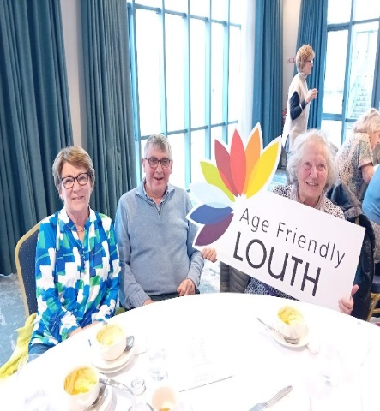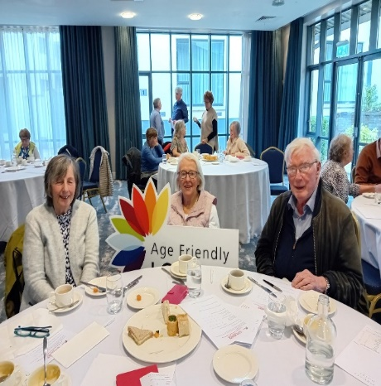

Attending the Let’s Talk Climate Action Workshop organised by Age Friendly Louth and Age Friendly Ireland

After lunch the participants were treated to a tour of the award-winning Blackrock Park.

Local Link provided free transport to and from the hotel to the nearby park.

Eileen Guiney along with a team of tidy towns volunteers work tirelessly with the Blackrock Park Committee to keep the park looking great and they have implemented a number of green and sustainable initiatives to help with biodiversity throughout the park.

Eileen provided a guided tour of the park and explained the idea behind the planting of various trees, shrubs, hedges and flowers. She also explained the many biodiversity and green practices and initiatives in place across the park.

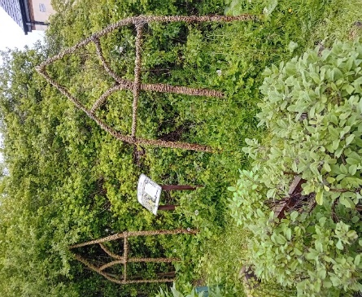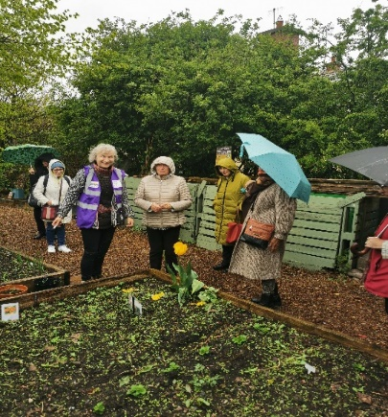

Guided tour of Blackrock Park, Co Louth as part of the Let’s Talk Climate Action Workshop

Age Friendly Conference Kilkenny City

Members of Louth Older People’s Council (OPC) and the Age Friendly Louth Team attended the Age Friendly Conference in Kilkenny City on 9th & 10th May 2024.

The theme of the Conference was Ageing with Independence and Louth OPC members agreed a number of key priorities for the OPC’s to deliver in 2024.

These include challenges around a cashless society and lack of access to toilet facilities in public places and on public transport.

The members will inform their local OPC of these priorities for 2024 and will work towards addressing these issues with the Louth Older People’s Council (OPC), local Alliance and Age Friendly Program Manager.

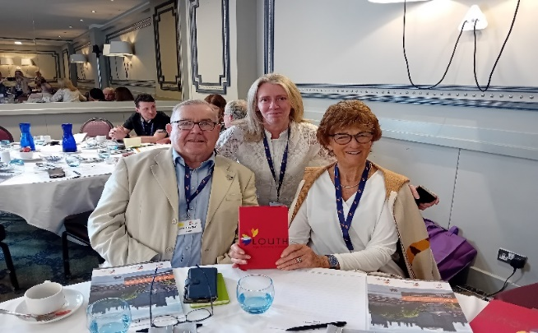

Joe Grogan, Chairperson Louth OPC, Louise Larkin Louth Age Friendly Team & Venora O’Brien Louth OPC at Age Friendly Ireland Conference in Kilkenny

Creative Ireland – Drama Workshops Challenging Ageism in Co Louth

Age Friendly Louth have been successful in securing €11,000 funding from Creative Ireland to explore the topic of ageism in Co Louth through the medium of creative arts.

Age Friendly Louth have partnered with An Táin Arts Centre to deliver this project, which will promote positive ageing and reframe the conversation around ageism.

A number of taster drama workshops were rolled out across Drogheda, Ardee & Dundalk during May, inviting adults and especially older adults to take part in initial workshops.

A wide variety of people from lots of different backgrounds across Co Louth and with a wide range of ages and abilities attended the drama taster workshops.

Those attending the taster workshops were subsequently invited to attend a suite of follow up workshops which will be held in An Táin Arts Centre every Monday during May, June & July to collaborate further on this project.

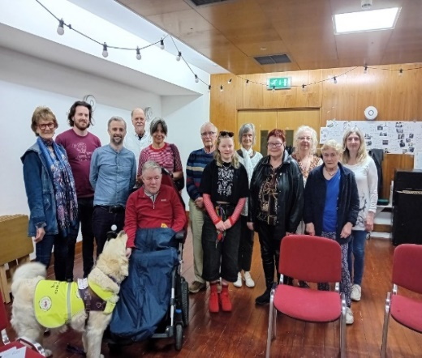

Participants at the Drama Workshop in Dundalk, exploring ageism in Co Louth

Age Friendly Healthy Homes

Age Friendly Louth were delighted to invite Adrienne McCann the new Age Friendly Healthy Homes Co Ordinator for Co Louth to give an overview on her role within the county.

Older people from across Co Louth were invited to attend the presentation and Adrienne explained the many ways in which the Age Friendly Healthy Home programme can help and assist older people to age independently at home and how people can refer into the programme.

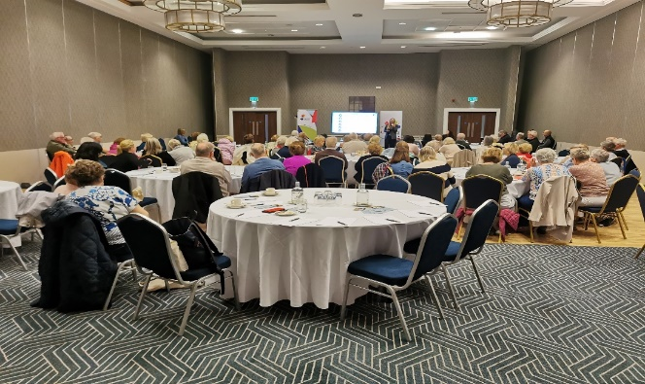

Attendees at the Age Friendly Healthy Homes Presentation

At the same event, over 75 older people and representatives’ of organisations supporting older people took part in an engaging workshop and discussed ideas and initiatives’ on how to reframe the conversation around ageing in Co Louth.

The Louth Older Peoples Council (OPC) and Age Friendly Alliance will work together with the Age Friendly Programme Manager to deliver on the ideas and initiatives over the next number of years.

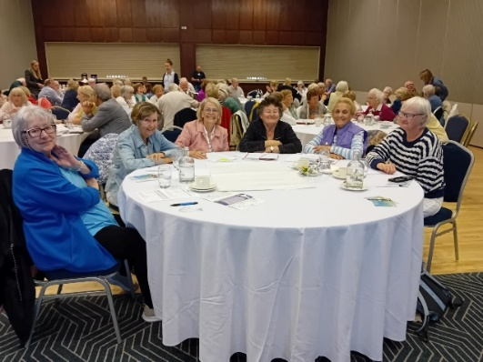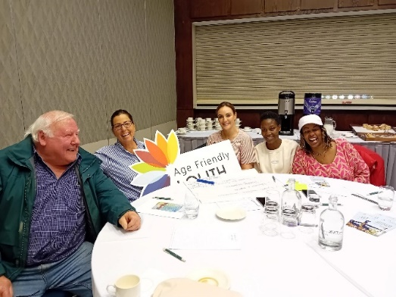

Participants at the Workshop in Challenging Ageism in Co Louth

Age Friendly Business Training Programme

A number of traders and business owners in across Co Louth attended Age Friendly Business Training workshops in Drogheda & Dundalk on 24th April.

The workshops were facilitated by Orlaith Carmody Business Consultant with Age Friendly Ireland. The purpose of the workshops was to assist businesses in Co Louth to achieve their Age Friendly Business Charter with a number of low-cost interventions to make their business more Age Friendly for older customers and shoppers.

Economic Development, in LCC will be working to assist the businesses and traders including local hotels, leisure services, banks, community-based businesses, small local businesses, service providers and wellness retailers over the next number of months to achieve their accreditation.

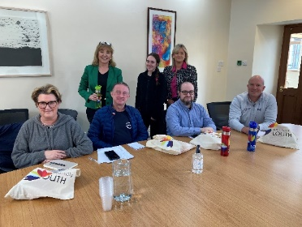
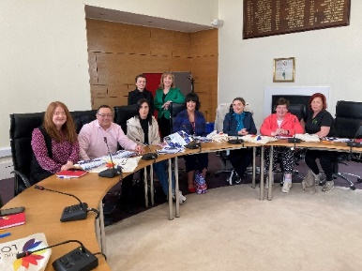

Age Friendly Business Training workshops in Drogheda & Dundalk

Members of the public were invited to spin and win prizes, vouchers and goodie bags.
The aim of the event was also to raise awareness around the Age Friendly Business Programme and to encourage other businesses in Co Louth to sign up to the Age Friendly Business Training Programme taking place on 24th April in Drogheda and Dundalk.

If you would like to take part in the training or if you have any queries, please contact Susan at econdev@louthcoco.ie

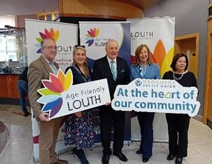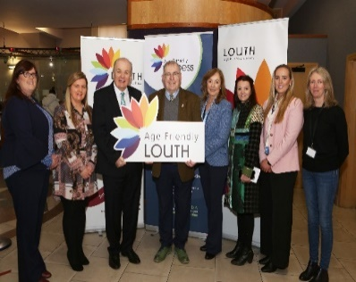

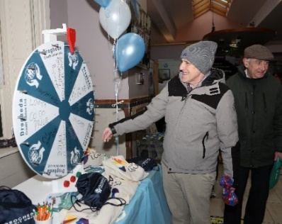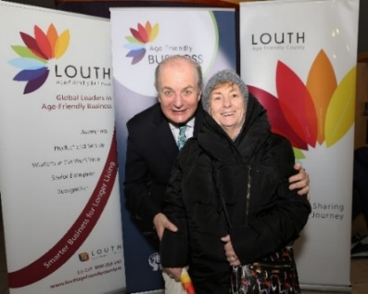

Assisted Decision Making Presentation

Age Friendly Louth hosted an Age Friendly Event in Drogheda on 6th March 2024.
Aine Flynn, Director of the Decision Support Service gave the attendees a presentation on Assisted Decision Making.

Aine outlined the rights and interests of people who may need support with decision making. She also outlined the role of the Decision Support Service which includes a registrar of decision support arrangements and supervision of decision supporters.

The presentation was followed by a Q&A session where attendees raised a number of queries and questions which Aine duly answered.

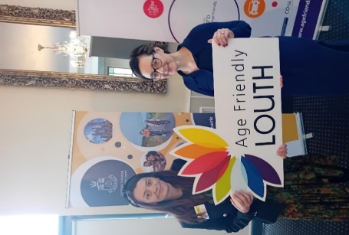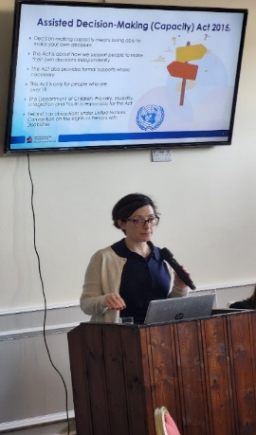

Ageism Awareness Workshop

The presentation was followed by an ageism awareness workshop hosted by Geraldine Johnson from Boyne Communications.

Participants discussed their experiences of ageism; this included their experiences in daily life where they felt they were judged or discriminated against because of their age. Attendees shared their experiences in shops, online or with the system in general.

Participants were also asked to suggest a name for an ageism awareness campaign and each table came up with a different suggestion.

Finally, the participants were asked to come up with several project ideas to challenge ageism and ideas such as intergenerational activities, linking older people with TY students, training and awareness raising events were discussed as a means of bringing all ages together.

Age Friendly Louth will be hosting a workshop on ageism in Dundalk/North Louth shortly, if you have ideas around combatting ageism please come along and share your thoughts and ideas. If you are interested in attending please contact agefriendly@louthcoco.ie or phone 042 9324389.

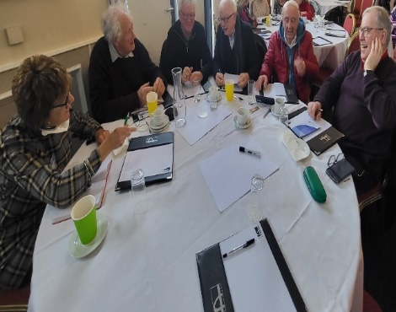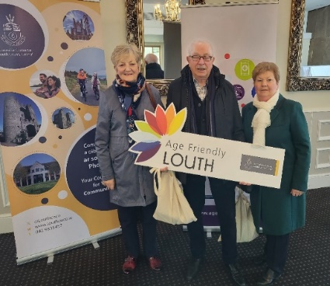

Disability Awareness Information Event

Members of the Louth Age Friendly Team attended the Disability Louth Awareness Information event in Ardee Parish Centre on Thursday 21st March 2024.

The event included a selection of services and supports for people living with disabilities in Co Louth.

Louth Age Friendly Programme Manager Sinead McVerry gave a presentation on the recent accessibility audit the Louth Age Friendly Programme facilitated in Drogheda.

The accessibility audit had 18 participants with a range of ages and abilities who travelled along a section of the R132.

The entire route was just under 1km and participants looked at the built environment including footpaths, roadways, lighting, signage and environmental factors.

The comments, observations and recommendations from the participants have been collated into a report and will be presented as a submission to the Joint Drogheda Local Area Plan which is on public display at present.
Other speakers at the Disability Awareness event included Maeve Montgomery, Louth Dementia Advisor and Julie Duffy Sports Inclusion Disability Officer with Louth County Council.

Age Friendly Louth Accessibility Audit

Members of Louth Older People’s Council, service users from the Irish Wheelchair Association and members of the public were invited to take part in an accessibility audit along a portion of the Dublin Rd, Drogheda on 26.02.2024.

The audit was conducted long a section of the R132 from the pedestrian lights located at the entrance to the Train Station along the R132 to the pedestrian lights located beside Scotch Hall, along both sides of the road.

This section of the R132 is a particularly busy part of the road with large volumes of cars, buses, HGV lorries, bikes, e scooters and pedestrians using the road on a regular basis.

Participants were looking at the physical built environment, including footpaths, roads signage, street furniture and also environmental conditions. Participants were commenting on the experience of navigating this section of road from the point of view of an older pedestrian or an individual with mobility issues.

Following the walkability audit participants held a debriefing session and discussed their findings and observations. All comments and observations will be collated into a report and presented to TCD, Louth County Council & presented as a submission to the Joint Local Area Plan for Drogheda.

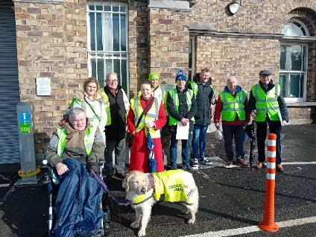

Members of the Age Friendly Team gave a presentation on the Age Friendly Programme to those attending the Dementia Café in Dundalk Library on 27th February 2024 and to the members of the Quality-of-Life SPC on 7th February 2024.

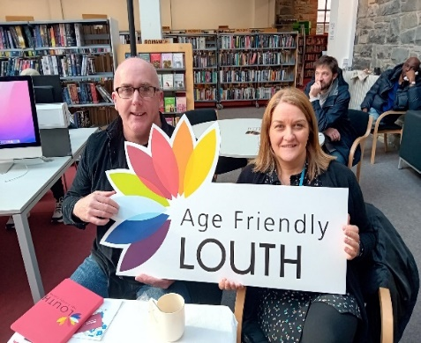
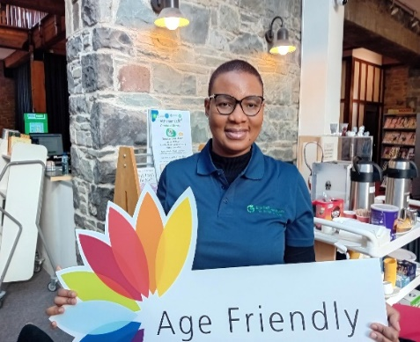

Louth OPC hosted Meath OPC at Netwell CASALA Centre, DKIT

Louth OPC were delighted to host members of Meath OPC at the Netwell CASALA Centre, DKIT on 24th January 2024.

The Netwell CASALA Centre is a research centre and Living Lab where staff, students and researchers design, develop, test and trial digital health and wellbeing solutions with and for older people, and those who care for and about them, to empower and support better and longer living in the community.

Suzanne Smith, center director gave the members a presentation on the centre and the projects and research that is being undertaken at the Living Lab.

ICPOP the Integrated Care Programme for Older People aims to improves the life of older people by providing access to integrated care and support that is planned around their needs and choices, supporting them to live well in their own homes and communities.

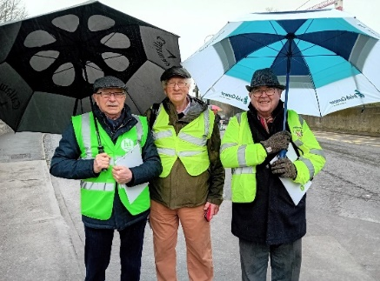
Erin Smyth, ICPOP Co Ordinator in Co Meath and her counterpart Dearbhla Birdy, ICPOP Co-Ordinator for Co Louth gave the members a joint presentation on the ICPOP programmes in both counties.

The meeting gave both OPC’s the opportunity to get to know each other and members robustly discussed the topic of ageism, particularly the issues of ageism in the print and tv media. Members discussed a selection of birthday cards with ageist images and ageist messages and how the images and messages can be negatively internalised.

Members also discussed examples of ageism which they had experienced in their lives and they were particularly vexed with health screening programmes which had an age cut off point, they strongly felt that such programmes should be related to need and not specifically age.
Louth OPC will examine these issues further in 2024 as they roll out a suite of ageism awareness initiatives.

It is anticipated the Louth OPC will arrange a return visit to their colleagues in Co Meath later in the year.

