Louth County Council

Gen
der
Pay Gap Report 2022

Louth County Council

Gen
der
Pay Gap Report 2022


Louth County Council
Gender Pay Gap Report 2023

Contents

1. Introduction

2. About us
- Local government in Ireland
- Louth County Council

3. Gender Pay Gap Reporting
- Gender Pay Gap Reporting 2023
- Who is included?
- What do we mean by the Gender Pay Gap?
- Mean and Median Gender Pay Gaps
- Quartile Pay Bands
- Bonus and benefit-in kind
- Factors that can have an impact on the Gender Pay Gap

4. Our figures
- All employees
- Part-time employees
- Temporary employees
- Benefit-in kind
- Bonus payments

5. How we are supporting gender equality

1. Introduction

The mission of Louth County Council is ‘to provide leadership and deliver high-quality, citizen-focused, responsive and effective services’.

A diverse workforce is a key element in supporting this mission, and we continue to strive to promote and sustain an inclusive organisational culture which provides equality of opportunity and where every employee feels valued.

Louth County Council is a place where all employees have the same opportunities for recognition and career development and are treated fairly and equitably at work.

We continue to be committed to addressing workplace barriers to equality, supporting diversity and creating an open and inclusive workplace community.

2023 is the second year in which Louth County Council has reported on our Gender Pay Gap and we welcome the opportunity to do so and to examine what the figures in the report can tell us about our organisation and how they can help inform our action plans.

The fact that many equality, diversity and inclusion initiatives and supports are already in place in Louth County Council is reflected in the figures in this report, however we recognise that improvement is always possible and we will continue to monitor trends in this area over the coming years and to work with our colleagues across the sector to share best practice.

I look forward to the continued development of Louth County Council as an employer of choice attracting and developing an inclusive and diverse workforce.

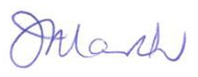
__________
Joan Martin
Chief Executive

2. About us

Local government in Ireland
There are 31 local authorities and 3 regional assemblies in Ireland. Local authorities are the closest and most accessible form of government to citizens. They have responsibility for the delivery of a wide range of services in their local area, with a focus on making cities, towns, villages and the countryside attractive places in which to live, work and invest. Local authority services make a significant contribution to the physical, cultural, social and environmental development of communities and include housing, planning, infrastructure, environmental protection and the provision of amenities and recreation and community infrastructure.

Local authorities play a key role in promoting social inclusion and quality of life and supporting economic development and enterprise at a local level. Local authorities take the lead role in shaping the strategic vision of the county or city. They also work in partnership with other state, public and private bodies in the delivery of critical infrastructure and shared services. Local authorities deliver hundreds of services and implement policy across a range of areas including:

Arts and culture
Climate action
Community services
Economic development
Environment
Housing
Libraries
Parks and open spaces
Planning
Roads and transport
Tourism

Local authority employees come from a wide range of backgrounds with diverse skill sets, qualifications and experience. Roles in the sector include:

Accountants
Administrators
Architects
Archivists
Engineers
Fire services
General service and tradespeople
Graduates
Health and Safety
Information technology
Library services
Planners
Senior management roles
Technicians

Working for Louth County Council gives our employees the opportunity to gain experience at the heart of local government and to make a real difference for County Louth. Everything we do in Louth County Council is geared towards making County Louth a great place to live and work and our employees play a vital role in that ambition.
Louth County Council
Louth County Council is the authority responsible for local government in Louth. The Council provides a diverse range of services across a large geographic area.

Louth County Council seeks to enhance the county’s attraction as a place in which to invest, work, and live, and takes the lead role in shaping the strategic vision of the county.

Key service areas include housing delivery, community services and facilities, encouraging economic development through foreign direct investment, the Local Enterprise Office supporting business start-ups, emergency services, infrastructural upgrades and projects (road improvements, public realm).

Louth County Council employs a workforce of approximately 800 employees. We offer excellent career opportunities across administrative, professional, technical and general services roles.

Our employees work in a dynamic and progressive local authority which promotes training and development of our employees who are our most valuable resource.
Find out more about the varied roles on offer and job vacancies on our website www.louthcoco.ie
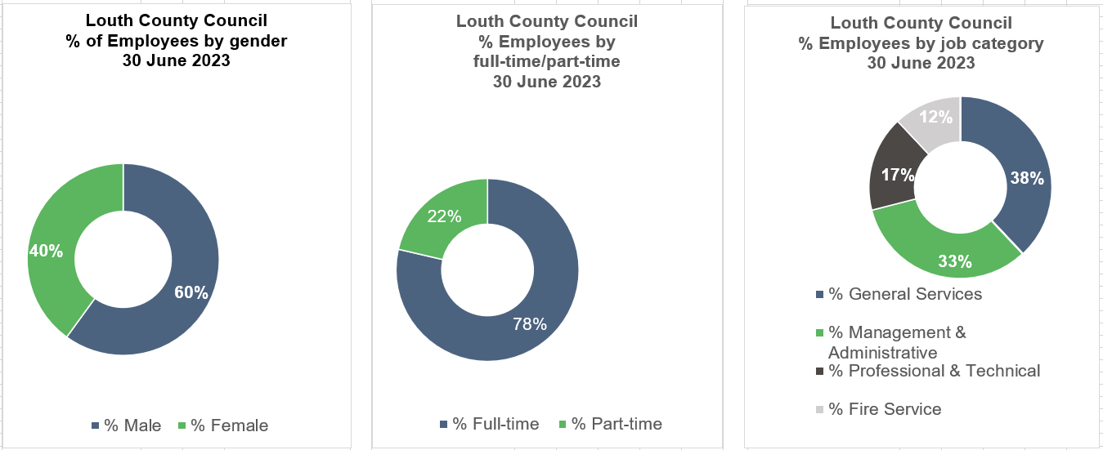

3. Gender Pay Gap Reporting

Gender pay gap reporting 2023
The Gender Pay Gap Information Act, 2021 requires organisations with over 250 employees to report on their Gender Pay Gap. 2023 is the second year that organisations will have to report on their Gender Pay Gap. Organisations are asked to select a ‘snapshot’ date in the month of June. The reporting period is the 12-month period immediately preceding and including the snapshot date, which for local authorities is 30 June 2023. Organisations have six months to prepare their calculations, before reporting six months later during December 2023. The information must be published on the employer’s website or in some other way that is accessible to all its employees and to the public.

Who is included?
All persons employed by the employer on the snapshot date, including employees not rostered to work on that date and employees on leave. The mean and median figures must also be given separately for part-time and temporary employees.

What do we mean by the gender pay gap?
The Gender Pay Gap calculates the percentage difference between the average earnings of males and females irrespective of their role. The Gender Pay Gap is not the same as equal pay. Employment Equality legislation provides for equal pay for like work. All male and female employees in the local government sector are paid equally for work that is the same or similar or for work of equal value, therefore this report does not examine equal pay. Rates of pay within the sector are agreed through national wage agreements negotiated regularly between employers and staff representatives. Most employees are paid according to an incremental salary scale and the salary ranges for various roles are available on the local government jobs website at www.localgovernmentjobs.ie

Mean and Median Gender Pay Gap
The Gender Pay Gap calculates the percentage difference between the average earnings of males and females irrespective of their role, using the following measures:

MEAN GENDER PAY GAP
This shows the % difference between the
average hourly rate of pay for males
and
average hourly rate of pay for females

(average male hourly rate) – (average female hourly rate) x 100
average male hourly rate

MEDIAN GENDER PAY GAP
This shows the % difference between the
median hourly rate of pay for males
and
median hourly rate of pay for females

(median of male hourly rates) – (median of female hourly rates) x 100
median of male hourly rates

The mean is the average. It is calculated by getting the difference between the average hourly rate of pay for males and the average hourly rate of pay for females (male hourly rate minus female hourly rate), expressed as a percentage of the male hourly rate. If this figure is negative, the average hourly rate of females is higher than the average hourly rate of males on the snapshot date. If this figure is positive, the average hourly rate of males is higher than the average hourly rate of females on the snapshot date.

The median is the figure that falls in the middle of a range where the salary of all relevant employees is listed, from the lowest to the highest. This can provide a more accurate representation of the ‘typical’ differences in pay.

It is useful to look at both the mean and median figures, as each one can tell us something different about the underlying factors affecting the pay gap. For example, a small number of higher paid employees can impact the mean figure and if this is the case, the median figure may be more representative of difference between what a male and a female is paid. If there is a significant difference between an organisation’s mean and median pay gap, this may indicate that the data is impacted either by the presence of very low earners (making the mean lower than the median) or by a group of higher earners (making the mean higher than the median). It is also important to remember that this report uses data on a snapshot date in June. Gender pay gaps can fluctuate from month to month and across quartile pay bands, depending on changes to headcount. However, headline figures will give a good indication of the differences between average earning between males and females.

Quartile Pay Bands
Dividing employees into four more-or-less equal groups (or quartiles) with pay graded from lowest to highest helps us to examine pay across different levels of the organisation. Organisations must report on the percentage of employees who fall within the lower, lower middle, upper middle and upper quartile hourly pay bands. In order to group employees into these Quartile Pay Bands, the organisation lists all employees from lowest to highest, based on their hourly rates. The employees are then divided into four equal groups or Quartiles based on this - lower, lower middle, upper middle and upper. The employer then shows the proportion of male and female employees in each quartile as a percentage e.g. percentage of male employees in the lower quartile and percentage of female employees in the lower quartile (and so on).
Bonus and benefit-in-kind
Figures must also be provided for bonus payments or benefit-in-kind payments if these apply. Bonus payments do not apply within the local government sector.
Benefit in Kind may arise in certain circumstances, such as where some professional fees are paid by the employer.

Factors that can have an impact on the gender pay gap
As mentioned, this report does not look at equal pay. Every employee, regardless of gender is paid equally for work that is the same or similar or for work of equal value. However, differences between what employees are paid can be impacted by a number of complex factors including:

- Occupational segregation – some job categories or occupations may have traditionally attracted more females than males or vice versa.
- Working patterns – full-time and part-time work. It may be that more females than males seek part-time work or career breaks and although this does not impact on their hourly rate of pay, it may impact on choices around career progression.
- Length of service – incremental pay increases may mean that new joiners are paid less than more experienced employees.
- Time of year – temporary or seasonal workers may be recruited for different roles which may attract a different rate of pay.
- Gender breakdown of senior roles at higher salaries – a small number of higher paid employees can affect the average figures.
- Gender breakdown of lower paid roles – a large number of lower paid employees can affect the average figures.

If an organisation reports a positive gender pay gap, it does not mean that females are paid less than males for doing the same job, but it does show that, on average, males occupy higher paid roles than females.

If an organisation reports a negative gender pay gap, it does not mean that males are paid less than females for doing the same job, but it does indicate that, on average, females occupy higher paid roles than males.

The larger the positive or negative pay gap is, the more marked the differences in hourly rates of pay will be and the more males or females proportionally working in either higher or lower paid roles within the organisation.

4. Our Figures

Mean and Median Gender Pay Gap - all employees

Louth County Council Gender pay gap 2023
All employees for the reporting period to 30 June 2023
MEAN GENDER PAY GAP | MEDIAN GENDER PAY GAP
2.41% | -1.32%
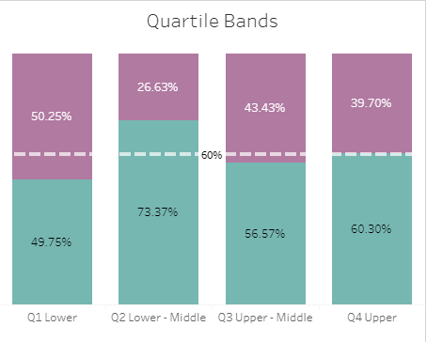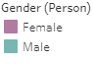

Note: 60%:40% (male:female) is the gender breakdown of all employees on 30 June 2023. This is shown in the dotted line above.

The Mean Gender Pay Gap shows that on average, males are paid 2.41% more than females. The Median Gender Pay Gap shows that the median rate of pay for females is 1.32% higher than the median rate of pay for males.

Looking at the distribution of employees across the four Quartile Pay Bands helps us examine pay at different levels of the organisation. These Quartile Pay Bands show the distribution of male and female employees by Pay Band across the organisation. (The organisation lists all employees from lowest to highest, based on their hourly rates, then divides this into four equal Pay Bands or Quartiles - lower, lower middle, upper middle and upper. The employer then shows the proportion of male and female employees in each quartile). The split for Bands 3 & 4 shown above is broadly in line with our workforce demographics of 60% male and 40% female. For there to be no Gender Pay Gap you would expect to see the workforce demographics reflected more closely in each quartile. There is a higher proportion of females in Band 1, reflecting that there are proportionately more females at lower grades. There is a higher proportion of males in Band 2, reflecting that there are proportionately more males in lower to middle grades. A 60%:40% gender breakdown in senior grades is to be welcomed and reflects progress on gender balance in senior roles.

Mean and Median Gender Pay Gap - Part-time employees

Louth County Council Gender pay gap 2023
Part-time employees for the reporting period to 30 June 2023
MEAN GENDER PAY GAP | MEDIAN GENDER PAY GAP
-2.8% | -2.41%

Approximately 22% of all our employees on 30 June were working part-time. Of these, 38% are male and 62% are female. Factors influencing the pattern of part-time employees across the organisation include a range of flexible work options for part-time work, which, while available to all employees, have a greater take-up in administrative and clerical job categories. Another factor is job categories where part-time work is an occupational feature of the role, including the fire service, library service, school wardens and caretakers for burial grounds.

Mean and Median Gender Pay Gap - Temporary employees

Louth County Council Gender pay gap 2023
Temporary employees for the reporting period to 30 June 2023
MEAN GENDER PAY GAP | MEDIAN GENDER PAY GAP
-3.79% | -4.05%

On 30 June 2023, 5% of our employees on were employed on temporary contracts. Of these, 63% are male and 37% are female. These contracts include temporary/seasonal employees such as lifeguards and general operatives, as well as relief school wardens and staff engaged on internships and graduate programmes.

Benefit in kind
On 30 June 2023, 0% of male employees and 0% of female employees received a Benefit in Kind payment.
Bonus payment
Bonus payments do not feature as part of pay in the local government sector.
5. How we are supporting Gender Equality

Fair and transparent recruitment practices
- As an equal opportunities employer, we work to promote a culture of equality and we strive to embrace genuine equality of opportunity through our recruitment and selection process which is open to all.
- We provide appropriate assistance and accommodation throughout our recruitment and selection process, including providing easily accessible interview facilities, agreeing an appropriately timed interview, and supplying or arranging appropriate equipment.
- All our Interview Boards are gender balanced and all Interview Boards receive training, including unconscious bias training.
- Recruitment websites highlight family friendly and flexible working options, and our job descriptions and job advertisements are gender neutral.
- We provide training and support, open to all employees, to help them prepare for job applications and interviews.
- Employees are paid according to an incremental salary scale, and we offer strong career progression opportunities which are open to all employees.

Work life balance
- We offer a wide range of flexible working and leave options which are available to all employees, including carer’s leave, career breaks, paid maternity and adoptive leave, paid paternity leave, parent’s leave, parental leave, shorter working year schemes and work-sharing.

Blended working
- Blended working is now a part of our flexible working policies with flexible options to combine office and home/hub working.
- We provide access to the Cycle to Work Scheme and the Tax Saver Scheme, to reduce commuting costs.

Learning and development
- We are committed to providing ongoing learning and development opportunities so that all employees can develop to their full potential. All employees are actively encouraged to pursue education opportunities through the Employee Training Assistance Scheme, with study and examination leave also available.

Health and Wellbeing
- The health and wellbeing of all employees is paramount and a healthy work-life balance is important to us. We offer comprehensive employee occupational health and wellbeing programmes including an Employee Assistance Programme, health screening, health advice and wellbeing webinars.

Dignity at Work
- We promote and support a culture of dignity, respect and equality.
- We operate a Dignity at Work Policy and all employees and managers have received training and support in the implementation of the policy

Equality, Diversity and Inclusion
- We are continually developing as an employer of choice to attract, develop and promote an inclusive and diverse employee population.
- We continue to design and provide responsive services and customer care that meet the needs of an increasingly diverse customer base.

Public Sector Duty
- We progressively embed the Public Sector Duty in our current management, policy development and service delivery processes.
- The Public Sector Duty is set out in Section 42 of the Irish Human Rights and Equality Commission Act, 2014. Section 42 requires a public body, in the performance of its functions, to have regard to the need to eliminate discrimination, promote equality of opportunity and treatment of its staff and the persons to whom it provides services and protect human rights of its members, staff and the persons to whom it provides services.
- We acknowledge the commonality of purpose stated in both the Public Sector Duty and Gender Pay Gap reporting requirements and the publication of this report serves to underline and support the three-step approach advocated by the IHREC i.e., Assess, Address and Report.

Gender balance in senior roles
- Our Senior Management Team comprises a gender balance of 60% Male and 40% Female which is in line with our workforce demographics of 60% male and 40% female. We will continue to work on maintaining gender balance in senior roles.

Data collection and evidence-based policy development
- We welcome the opportunity to report on our gender pay gap and have worked collaboratively across the Local Government sector to provide a standard and consistent approach to reporting. We will work with the Local Government Management Agency and our colleagues in other local authorities to share learnings and best practice.

