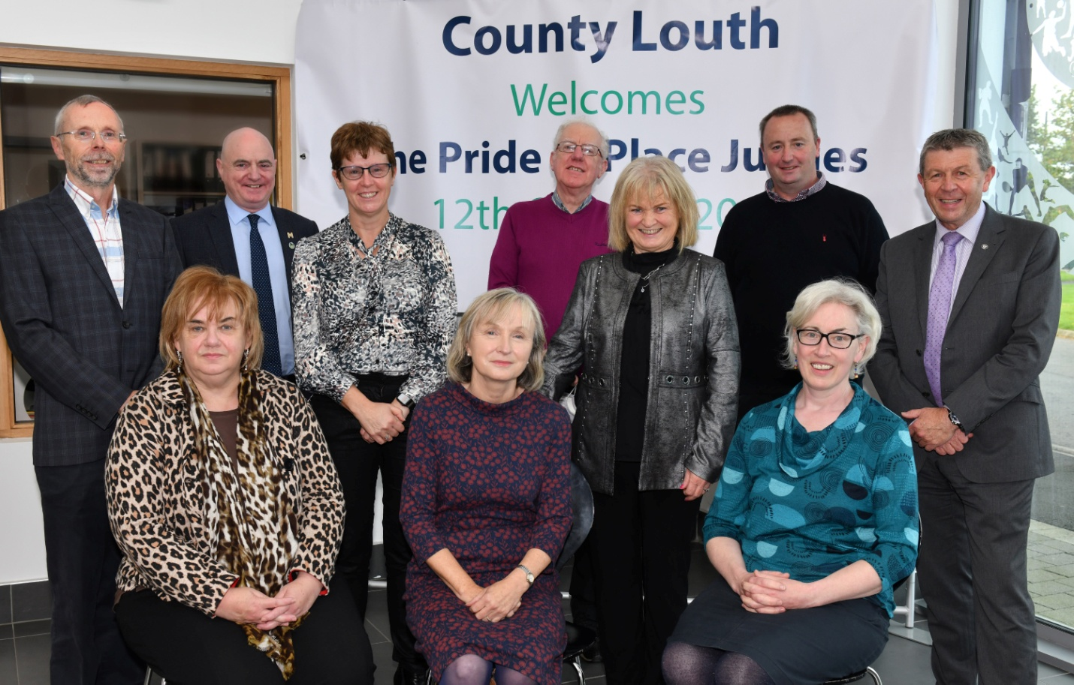
Pride of Place judges Katrina Murphy (seated 1st on right) and Peter Hynes (back 2nd from left) with Joan Martin, CE of Louth County Council, (seated 1st on left) Paddy Donnelly, Director of Service, (standing 1st from right) and members of the Blackrock Pride of Place team, Eileen Carter, Mandy Fee, Mary Murtagh, John Horan, Noel Sharkey, Brian Cafferty, at the Pride of Place judging held in the Dundalk Sports Centre.

