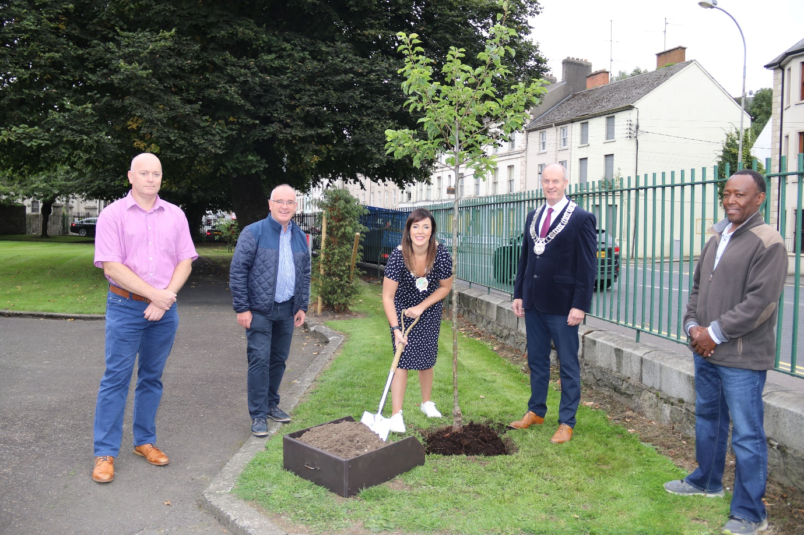
Chairperson Newry, Mourne and Down District Council, Councillor Cathy Mason planting an evergreen Ornamental Pear Tree in Corry Park, Newry along with l-r Jonathan Ellis Grounds Maintenance Manager, Councillor Declan McAteer Joint Chairperson Newry, Mourne, Down and Louth Council Strategic Alliance Committee, Chairperson Cathy Mason, Chairperson County Louth Council Councillor Pio Smith and Elias Mlimbila Park Superintendent.

