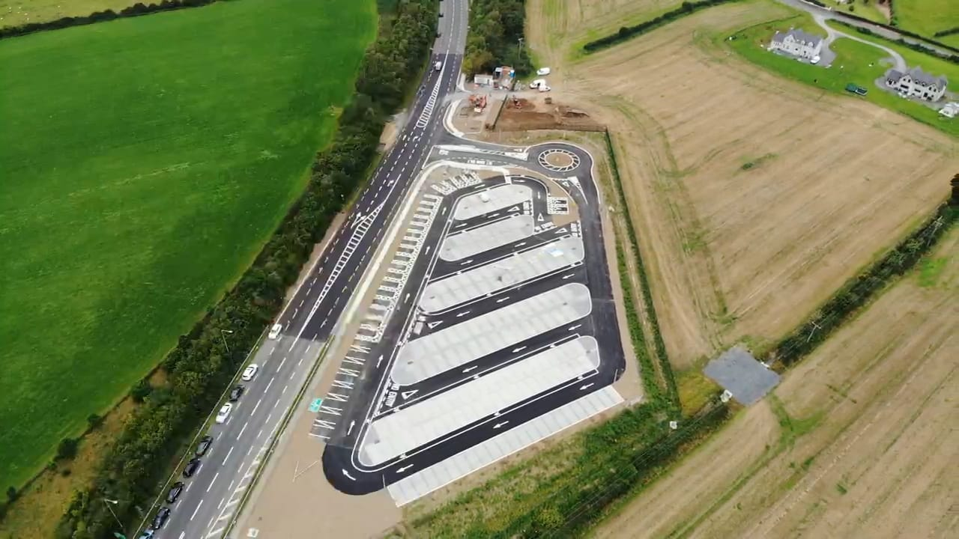
Picture 1: Aerial view of new Park and Share

